MYSQL PRACTICAL

Q1 : CREATE A DATABASE

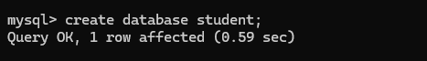

Q2 : USE DATABASE



Q3 : CREATE TABLE



Q4 : DESCRIBE TABLE

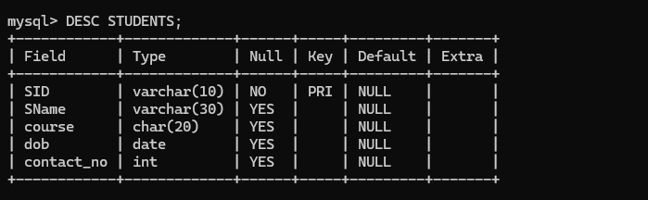

Q5 : INSERT VALUES

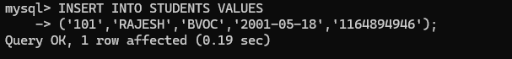

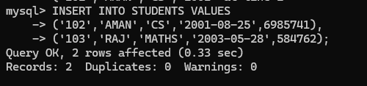

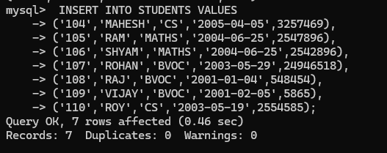

Q7 : SHOW VALUES FROM TABLE

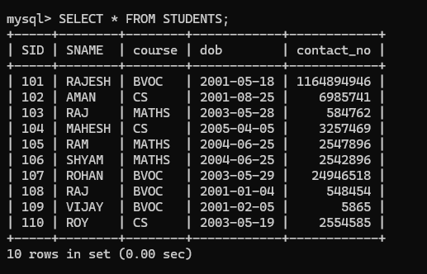

Q8 : FIND OUT THE NAME AND COURSE OF THE STUDENT WHOSE DATE OF BIRTH IS BETWEEN 2004 AND 2006.

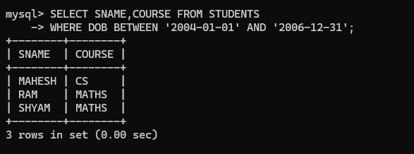

Q9 : DISPLAY THE STUDENT WHO IS STYDING IN CS COURSE.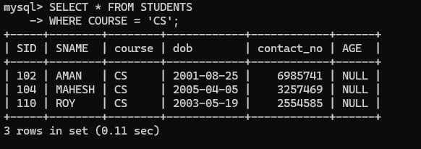

Q 10: CALCULATE THE AGE OF THE ALL STUDENTS.

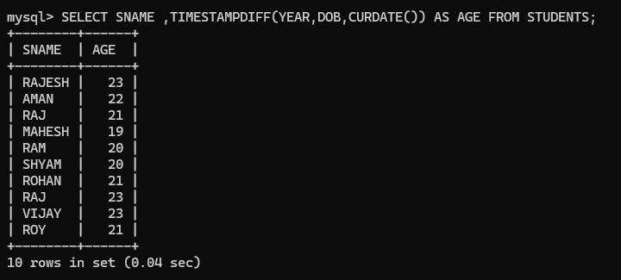

PRACTICAL 1

CREATE DATABASE STUDENT_COURSE

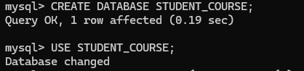

CREATE STUDENT TABLE



CREATE COURSE TABLE



CREATE ADMISSION TABLE

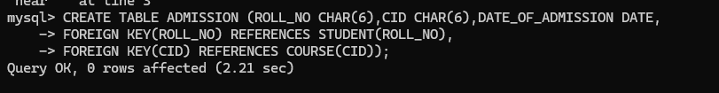

DESCRIBE STUDENT TABLE

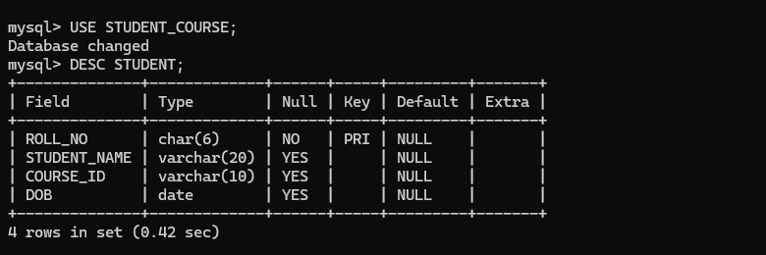

INSERT VALUES INTO STUDENT

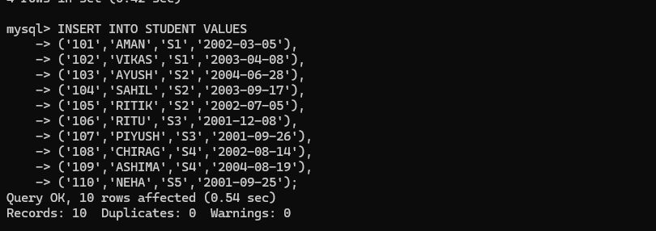

RETREIVE VALUES FROM STUDENT TABLE

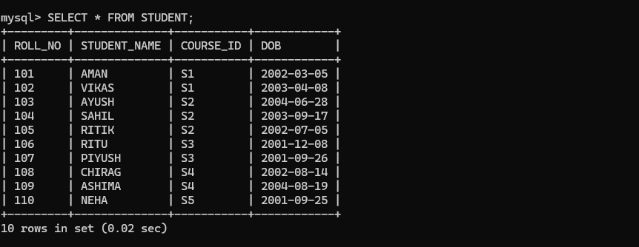

DESCRIBE COURSE TABLE

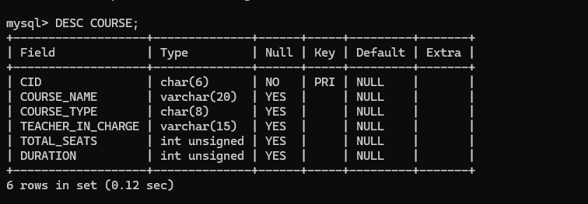

INSERT VALUES INTO COURSE

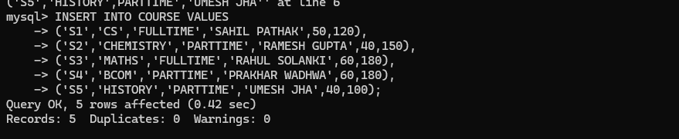

RETREIVE VALUES FROM COURSE TABLE

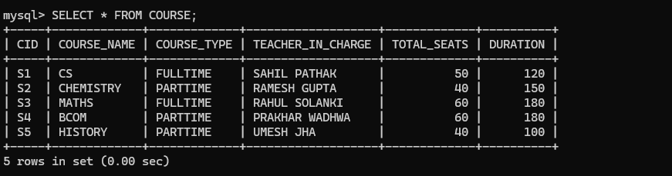

DESCRIBE ADMISSION TABLE

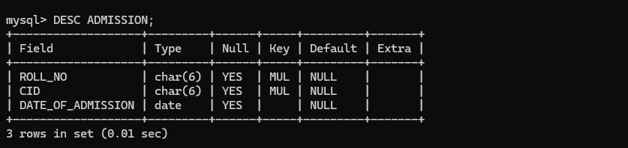

INSERT VALUES INTO ADMISSION

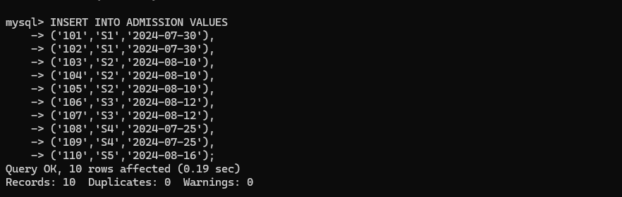

RETREIVE VALUES FROM ADMISSION TABLE

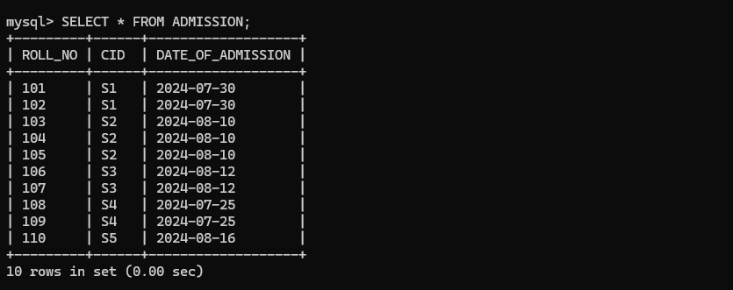

1. Retrieve names of students enrolled in any course.

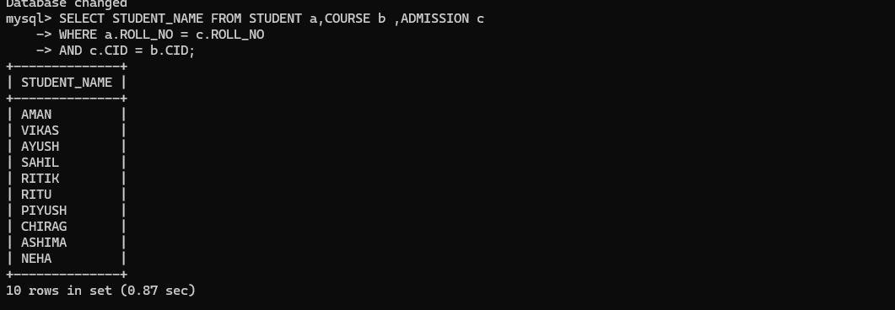

1. Retrieve names of students enrolled in at least one part time course.

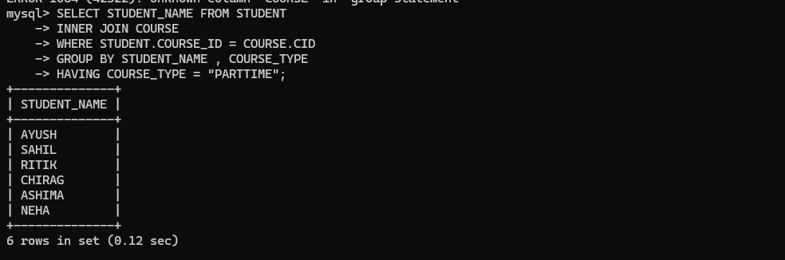

1. Retrieve students' names starting with letter ‘A’.

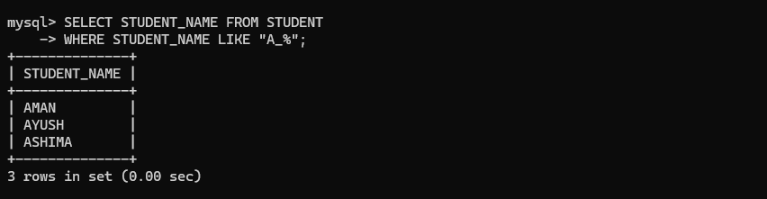

1. Retrieve students' details studying in courses ‘computer science’ or ‘chemistry’.

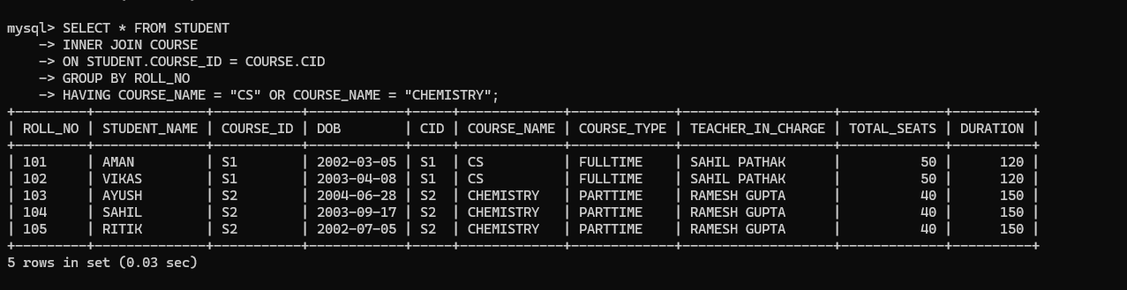

5. Retrieve students’ names whose roll no either starts with ‘X’ or ‘Z’ and ends with ‘9’

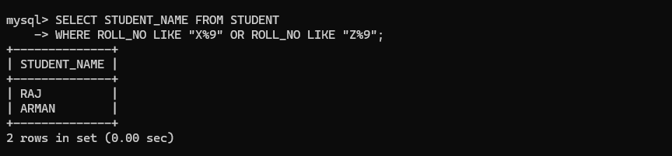

6.Find course details with more than N students enrolled where N is to be input by the user.



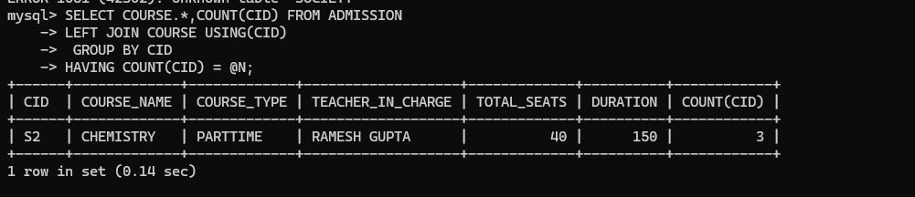

7.Update student table for modifying a student name.

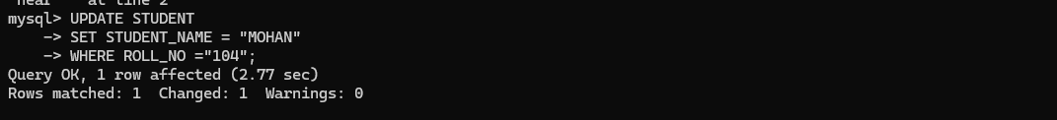

8. Find course names in which more than five students have enrolled

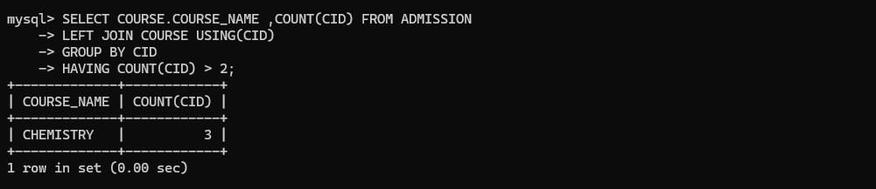

9. Find the name of youngest student enrolled in course ‘BSc(P)CS’

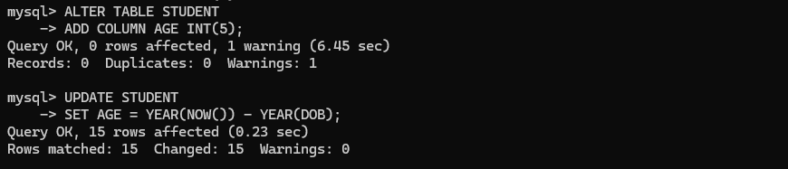

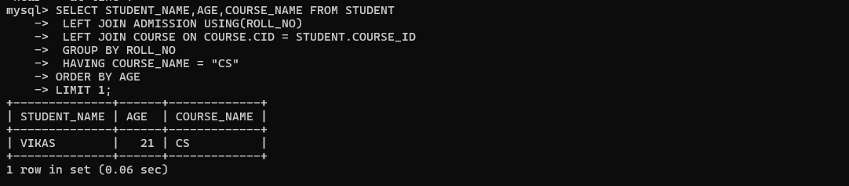

10. Find the name of most popular course (on the basis of enrolled students)

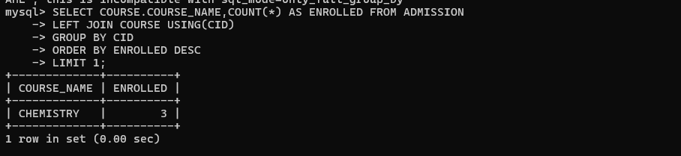

11. Find the name of two popular part time courses (on the basis of enrolled students)

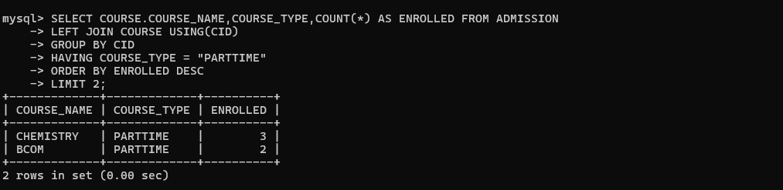

12. Find the student names who are admitted to full time courses only.

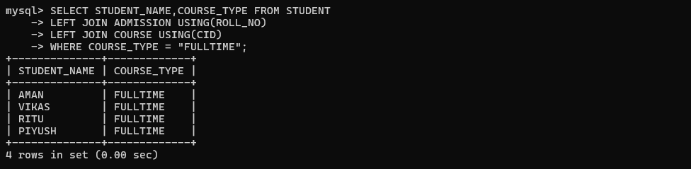

13. Find course names in which more than 30 students took admission.

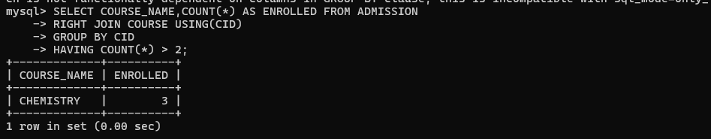14. Find names of all students who took admission to any course and course names in which at least one student has enrolled.

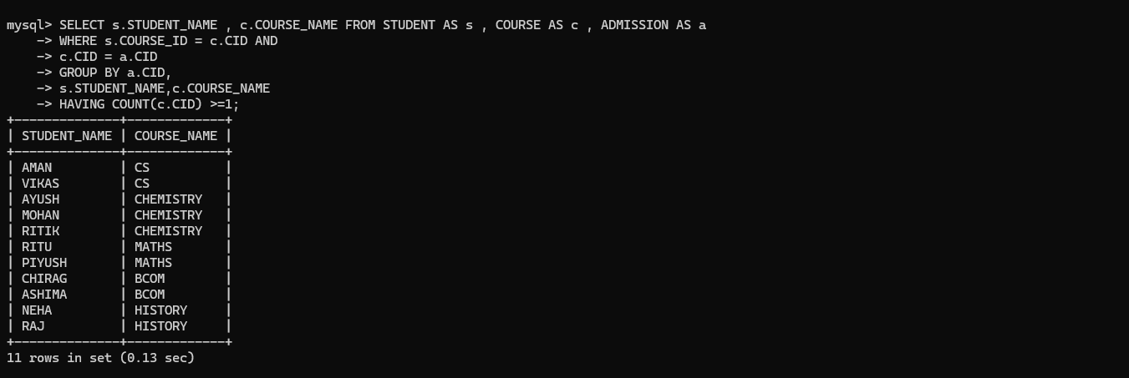

15. Find course names where teacher-in-charge has ‘Gupta’ as surname and the course is full time.

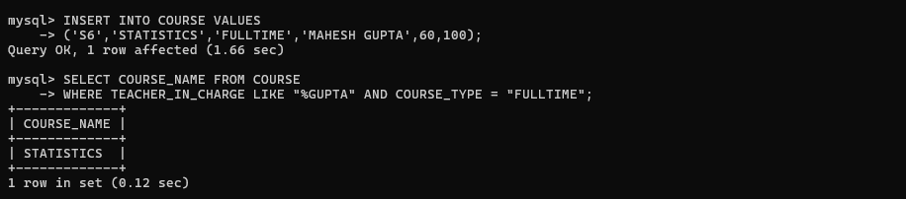

16. Find the course names in which the number of enrolled students is only 10% of its total seats.

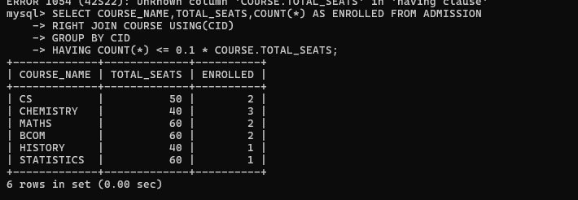

17. Display the vacant seats for each course .

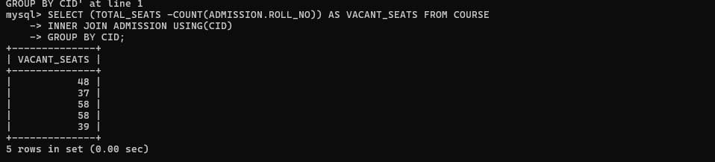

18. Increment Total Seats of each course by 20% .

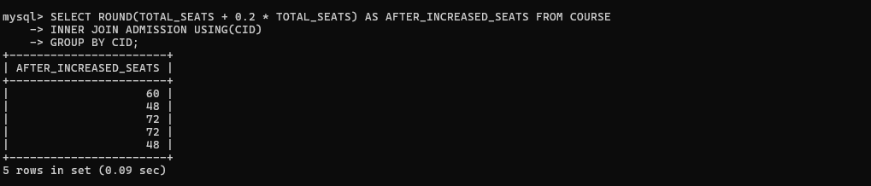

19. Add enrolment fees paid (‘yes’/’No’) field in the enrolment table.

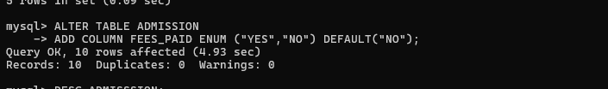

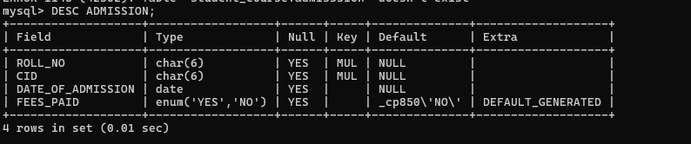

20. Update the date of admission for all the courses by 1 year.

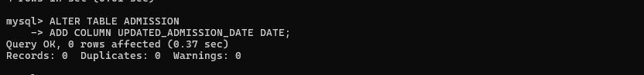



21. Create a view to keep track of course names with total number of students enrolled in it.

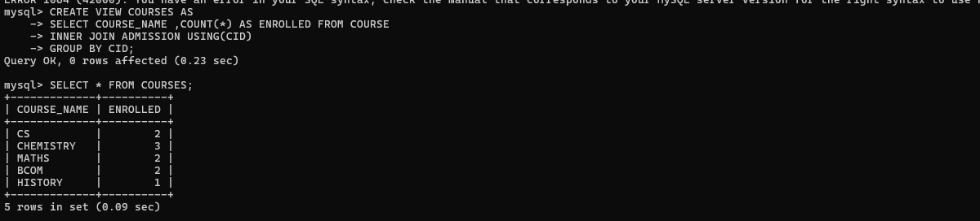

22. Count the number of courses with more than 5 students enrolled for each type of course.

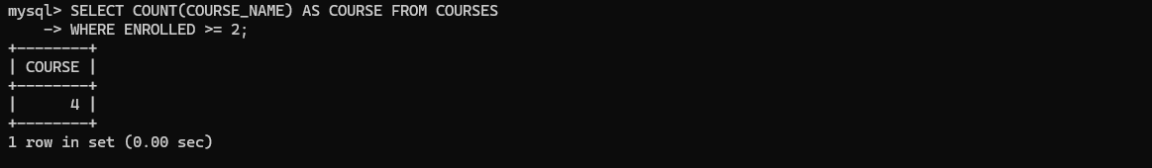

23. Add column Mobile number in student table with default value ‘9999999999’

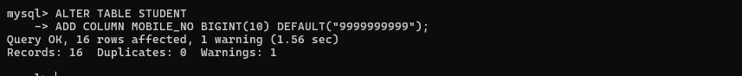

24. Find the total number of students whose age is > 18 years.

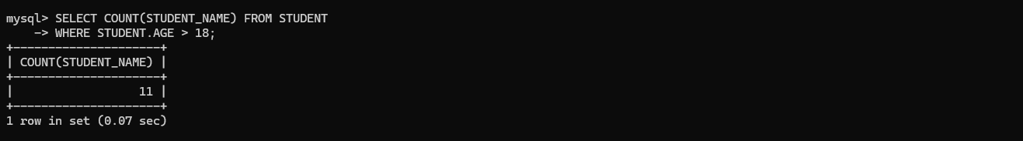

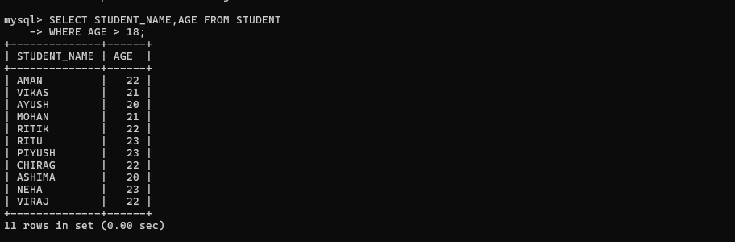

25. Find names of students who are born in 2001 and are admitted to at least one part time course.

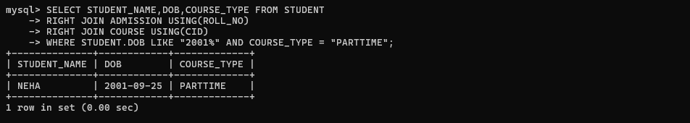

26. Count all courses having ‘science’ in the name and starting with the word ‘B.Sc.’.

